Who are our Role Models?

True role models are those who possess the nature that we would like to have and those who have affected us in a way that makes us want to change, be better and better.
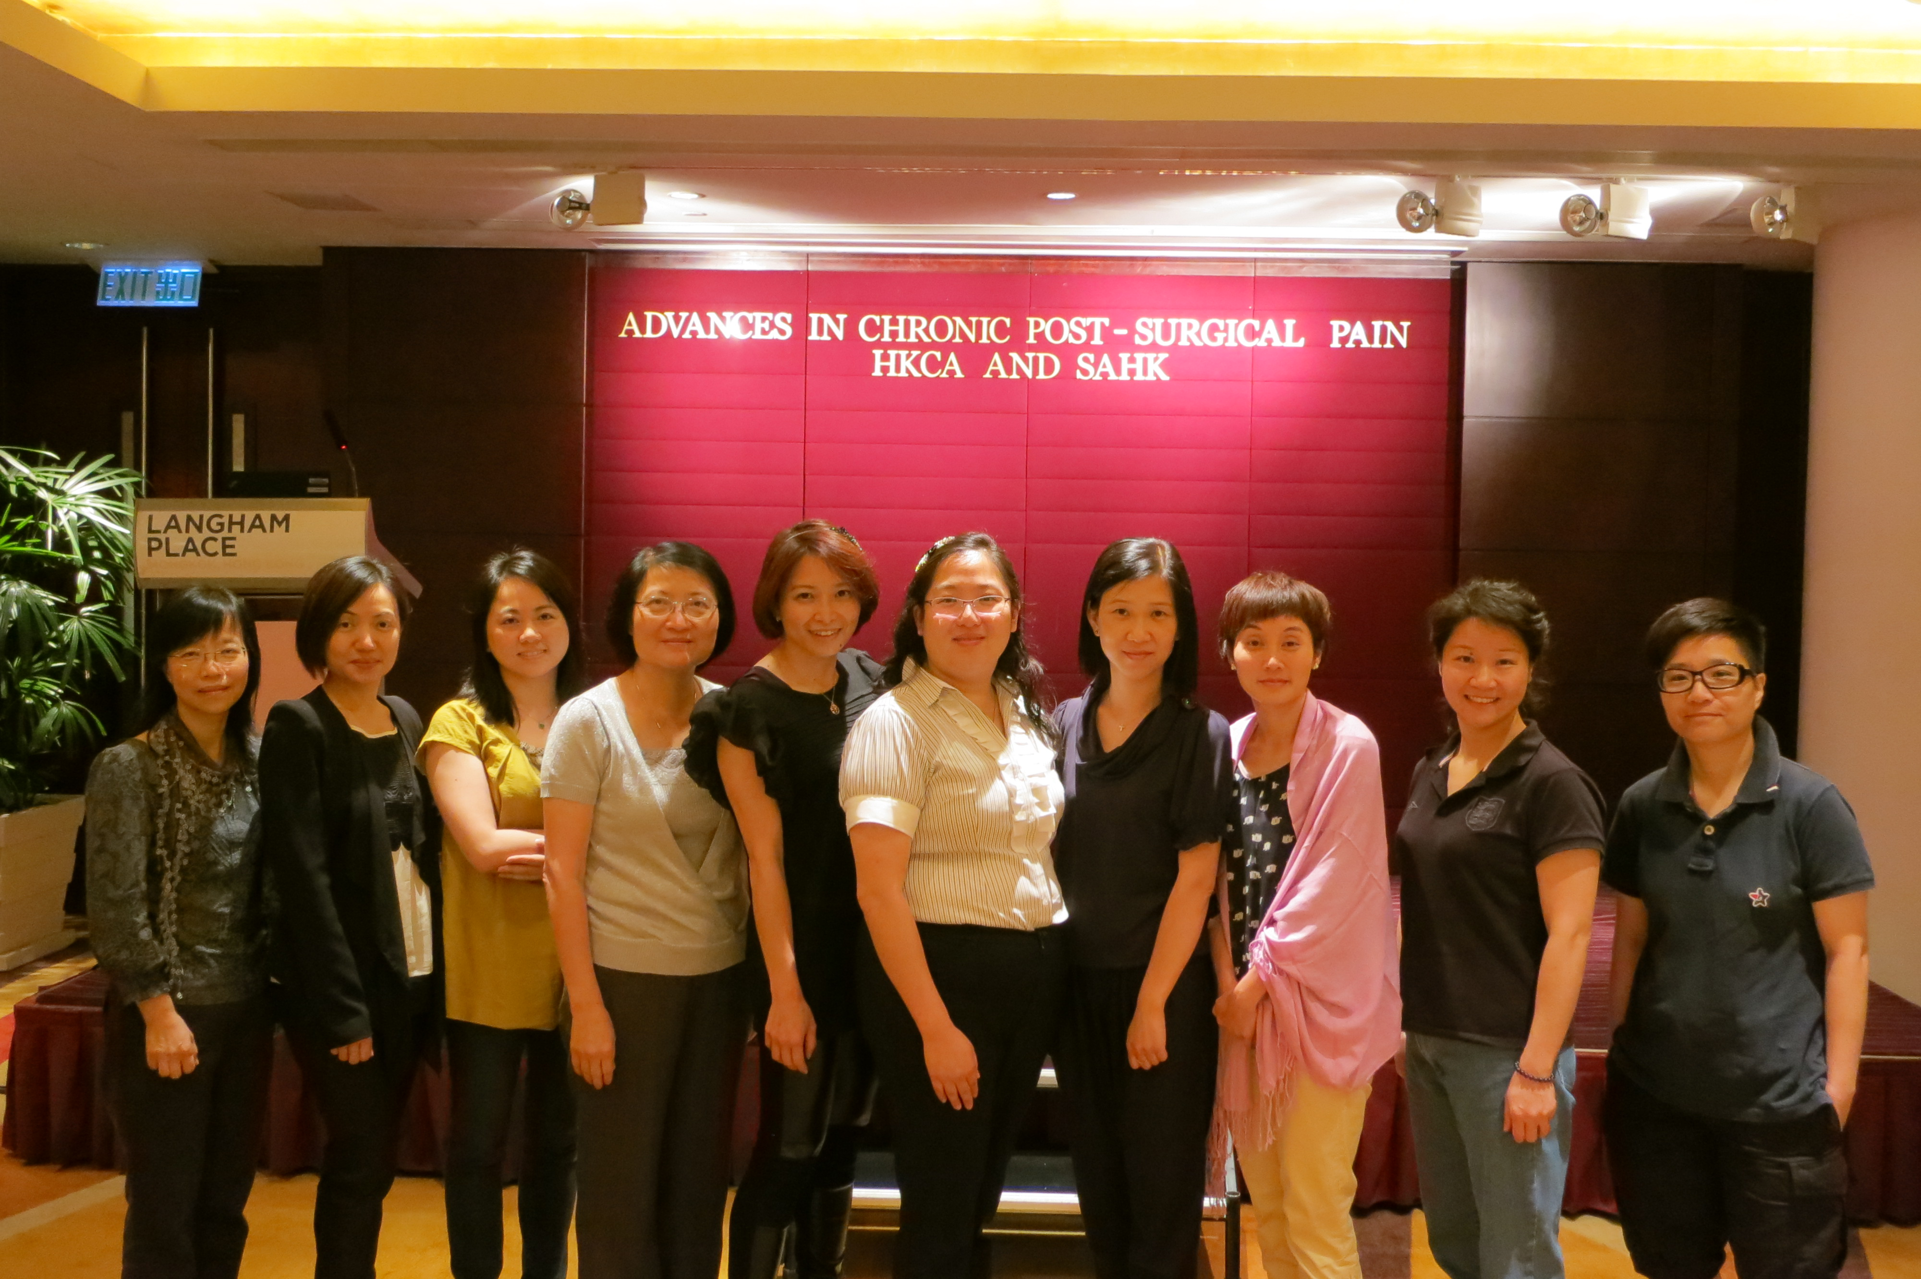
Wong Suk Ying and Michelle Wong are the two Hong Kong’s very first Nurse Consultants in Pain Management in Kwong Wah Hospital (KWH) and Caritas Medical Centre (CMC) respectively. They have mastered advanced and expert knowledge in peri-operative nursing before working as Nurse Consultants in Pain Management. They not only demonstrate clinical expertise and leadership abilities in pain management, they also possess their personal charisma.

Guiding her staff to do things right is Suk Ying’s leadership charm that provides greater working satisfaction and motivates for better performance. She once delegated appropriately the job of one of the staff who suffered from chronic pain. With Suk Ying’s support, she gradually got out of her initial low self-esteem and disconnected state and regained the sense of working ability. By listening to her heart, Suk Ying was able to address her innermost concerns. It proved to be a big step for the staff to back on the track again.

Suk Ying always motivates and praises her patients before they finish every session in the patient self-help class. Her great calling is to bring out their brilliance and potential. Gradually, the patients gain confidence and acquire the wisdom of self management. She helps them in accomplishing their goals by asking them to stand tall in front of a mirror and take a good look to sense the “Good”, “Control” and “Present”.

Suk Ying is as caring as Florence Nightingale. She always keeps herself well groomed. She would like to visit as many pre-operative patients as possible - even this means extra work in the evening. She would like to teach them how to manage their post-operative problems including surgical, physical and psychological problems. It is her hope that all major elective surgical patients will eventually be screened and educated about their appropriated pain management in a more timely and comprehensive way to reduce postoperative complications.

Michelle believes that every one of her staff has his or her own potential power. It is the job of the manager to motivate them through delegation and empowerment. In working with her staff, she would like to “over” supervise than “under” supervise in the positive way at the very beginning. By knowing more about the staff, she can be responsible for the process as well as the outcome of the work of the whole team. She often demonstrates what a good job looks like and shares the results with her team. With this established level of collaboration, they build up the mutual relationship to gain the effectiveness of the “changes”. In her philosophy, there is no difficult staff. The challenge is how to understand their difficulties. It is her belief that when a person is being judged as ‘difficult’, it undoubtedly impairs the manager’s ability to see his or her good qualities.

Michelle is a thoughtful, reflective and forward-thinker. She has a strong vision to promote quality improvement and risk management. She acquires the sense to pick out the seemingly minor points as prospects for major improvements. Michelle knows the value of a smile together with mutual respect and collaboration to bring out the best in her works.

Both Suk Ying and Michelle agree that the promotion to the Nurse Consultant is a great challenge – increasing personal workload and responsibilities; tackling problems in the multi-disciplinary dimension; and striving to get the higher quality. Sometimes, it is natural for them to wonder their own ability can meet the need. But they are not working alone. They are leaders of their competent teams.

Managing people is an art, not exactly a work. People are always better than you thought. All the praise, respect, positive guidance would be their nutrients for better career development. Our new Nurse Consultants are laying down the foundation of the nursing profession in pain management of our next generation.

With the establishments of the first fellowship of Pain Medicine in the Hong Kong Academy of Medicine and the Peri-operative Nursing in the Provisional Hong Kong Academy of Nursing, we have every reason to be confident that such development will synergize the interdisciplinary collaboration to enhance the services to our patients.

Authors: Flori LAM, APN & Yan Yan FOK, APN. Queen Elizabeth Hospital

